**Dimensionality of Community Response to Multiple Fertilizer Additions**

Date: 1/7/2019

**Overview:**

Trade-offs between different aspects of organismal function are a key concept in ecological theory are ubiquitous; assumed constraints on phenotypes are thought to explain the diversity of species and functional forms in many environments. The core notion of a trade-off – in which strong performance under some circumstances is balanced with poor performance in another – has played a central role in understanding community assembly and resource limitation in plant communities. To explain plant coexistence in variable environments, trade-offs in resource use assume that a plant’s ability to reduce the concentration of one limiting resource (e.g. soil nitrogen) is negatively correlated with its ability to reduce another (e.g. light).

While unique tradeoffs may exist for as many nutrients as are limiting in a system, plant species are also likely to exhibit the opposite pattern when physiological adaptations designed to capture one limiting resource may increase uptake of another. Specific root length, for example, may generally control plant absorptive capacity, correlating with the ability to compete for multiple belowground resources, such as soil N, P, or other cations. The addition of any of these nutrients is likely to produce a similar change in species’ abundances. In this case, the *inherent dimensionality* of community response to resource availability is lower than the dimensionality of the limiting resources themselves. In low dimensionality systems, simple gradients that reflect an aggregate of ecosystem attributes, such as belowground resource availability, may describe the majority of observed compositional gradients.

Ecological systems have long been observed to low inherent dimensionality, forming the basis for multivariate analysis methods, such as ordination. Explicit quantification of this dimensionality in response to simulated forms a powerful, yet often underutilized tool to understand and predict plant compositional shifts. Given that human activities are influencing the global availability of many limiting resources simultaneously, response dimensionality may be used to explore whether what environmental changes have similar compositional effects, and what characteristics define species that respond consistently to multiple stressors.

Experimental manipulations of soil resources in global grasslands have demonstrated that many systems are simultaneously responding to increased availability of multiple resources. Total community biomass often increases in response to the addition of nitrogen (N), phosphorous (P), and potassium + micronutrient (K) fertilizers (Fay et al. 2015), producing corresponding changes in species richness and composition (Harpole et al. 2016). Changes to community diversity and composition driven by multiple nutrient addition are theorized to be the result of *reduced niche dimension*, where fertilization reduces the meaningful variation in a limiting resource (Harpole et al. 2016, Harpole and Tilman 2007). While changes across these dimensions of resource supply are known to affect community-level attributes, effects on individual species abundances are less understood.

Despite the multi-dimensional nature of resource limitation in these systems, species responses are likely characterized by lower dimensionality. Fertilization is known to shift competition for belowground resources to competition for light in grassland systems, often selecting for species with larger maximum height and greater proportional investment into above- vs. belowground biomass (Cleland et al. 2019). If all fertilization treatments tend to select for taller, fast-growing species, community responses may be well-captured by a single dimension of compositional change – species are distributed as a function of belowground nutrient supply, independent of nutrient identity.

Conversely, differences in resource demand and acquisition rate may drive between-treatment variation in species responses. Phosphorous enrichment, for example, may disproportionately increase the abundance of legume species through elevated rates of nitrogen fixation. Generally, more specialized patterns of resource use are likely to produce greater dimensionality in community response.

Here, we aim to determine how experimental addition of multiple mineral nutrients drives changes in species composition across the Nutrient Network. Specifically, we assess the dimensionality of community response to single nutrient fertilization. Do species tend to show consistent responses to fertilization treatment, across all treatment types?

**Methods:**

1. Select NutNet sites with at least 5 years of data, and filter to plot with single nutrient enrichment treatments (+N, +P, +Kµ) and control.
2. Prior to analysis, community data was transformed with a log2 transformation to achieve normality in multiple linear regression and present changes in species abundances on a meaningful scale, where a 1-unit increase or decrease in response reflects a 2-fold change in abundance.
3. To estimate species responses to treatment, we fit the following multiple linear regression model to each site:



Where the abundance of species *j* at observation *i*  is estimated as a function of site-level interannual variation in abundance (βyr), spatial variation between blocks (βblock), and the effect of treatment (βtrt). Following other analyses of Nutrient Network data, we assumed that fertilization treatment effects saturated over time. We therefore log-transformed the number of years of treatment (*log(YrTrti + 1))*.

Model fitting yielded three regression coefficients for each species represented within a site -- βN, βP, βK – that capture the estimated rate of change in abundance in response to fertilization treatment. By focusing on response coefficients, we attempted to account for variation attributable to inherent temporal and spatial variation within a site, and standardize across sites with different experimental durations.

1. To estimate the dimensionality of community response to nutrient enrichment, vectors of estimated fertilization response – consisting of βN, βP, βK estimated for *j* species in a site – were standardized to unit length (divided by *L2* norm). Estimated response coefficients were then plotted in three dimensions and analyzed using Principal Component Analysis (PCA). Following Donohue et al. (2013), dimensionality was quantified using the eigenvalue of the first principal component.

Conceptually, this methodology is similar to PC decomposition of fitted values in redundancy analysis (RDA). However, by standardizing vector length and focusing on response coefficients, we attempt to better compare across sites with different experimental durations, independently of the magnitude of total treatment effect.

1. Pairwise comparisons between estimated fertilization effects were used to better identify the influence of functional groups structuring species responses. Regression lines were fit to pairwise response coefficients using major axis regression, which preserves correlation between two or more response variables. Regression line slopes were allowed to vary by species functional group identity – legume, forb, grass, and woody. Differences in functional group slopes were assessed using permutation tests with 9999 permutations and adjusted using the Sidak correction.

**Figure 1:**

Conceptual diagram illustrating low dimensional (a-c) and high dimensional (d-f) community responses to enrichment of nitrogen (N), phosphorous (P), and potassium and other micronutrients (K). In a low dimensional system, species responses to different limiting nutrients are strongly inter-correlated (a). The resulting 3-dimensional visualization of these species responses (b) are captured by a linear ellipsoid, which may be decomposed in a principal components analysis (PCA) where a single dominant eigenvector, “PC1”, accounts for a large proportion of the overall variance. In a high-dimensional system, species responses to different limiting resources are not correlated (d), producing a spherical ellipsoid in 3-dimensional space (e). The resulting PCA decomposition shows more even apportioning of variance across the three eigenvectors (f).

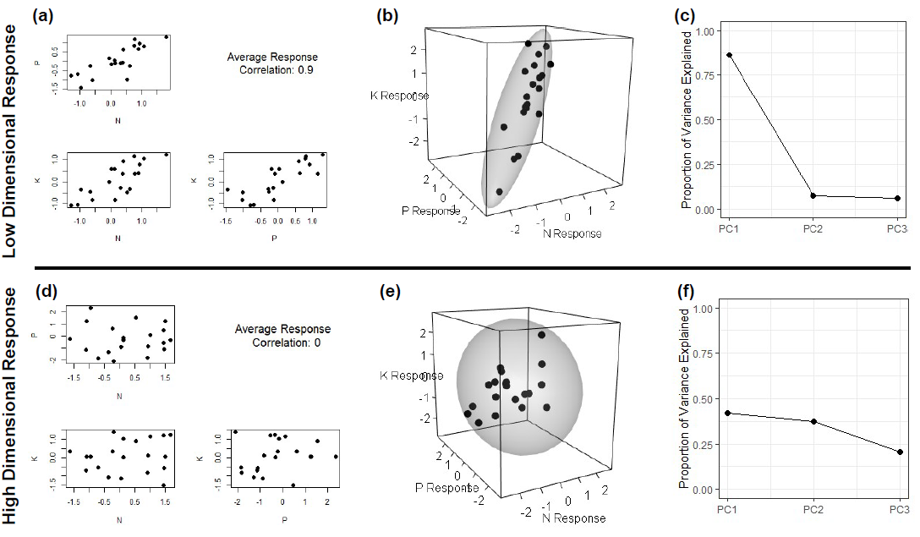

**Figure 2:**

1. Frequency of sites exhibiting significant (p < 0.05) effects of experimental fertilization on plant community composition. Of 50 total sites, 35 showed significant compositional changes to all three fertilization treatments, while 1 site showed non-significant compositional responses to all fertilization treatments.
2. Rate of estimated fertilization-driven change in species composition. The rate of total compositional change was calculated as the magnitude of the vector of estimated species response coefficients, estimating net change in log2-transformed species cover per log-transformed of treatment. Higher values indicate greater overall rate of compositional change.

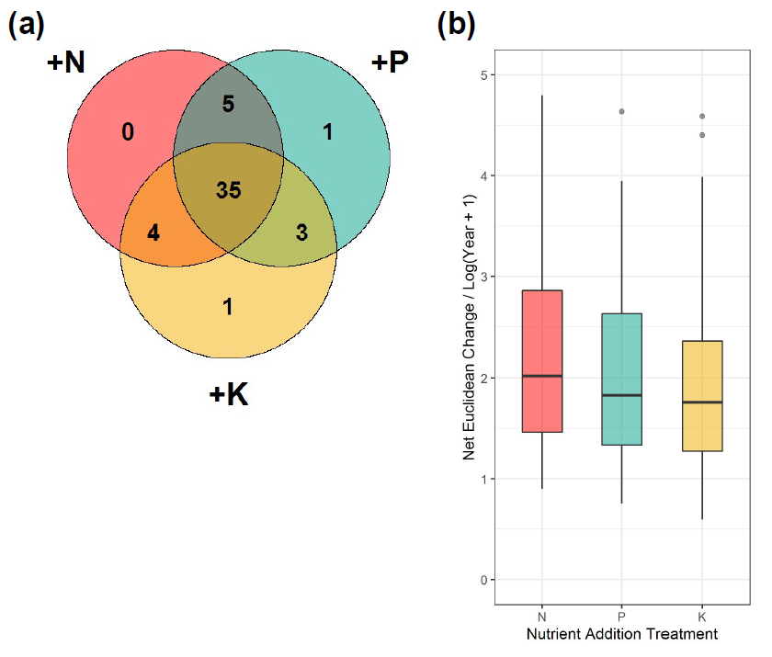

**Figure 3**

Three-dimensional visualization of species responses to fertilization treatments (Figure 3a) and associated principal components analysis (PCA) screeplot (Figure 3b). Positive correlations between estimated species responses produce an ellipsoid with a dominant first axis, as a majority of the overall response variation may be captured by the first eigenvector (Table 1). Permutation-based test of the magnitude of the first eigenvalue (PC1) is statistically significant (*p* < 0.01), indicating that the observed response pattern exhibits lower dimensionality than would be expected at random.

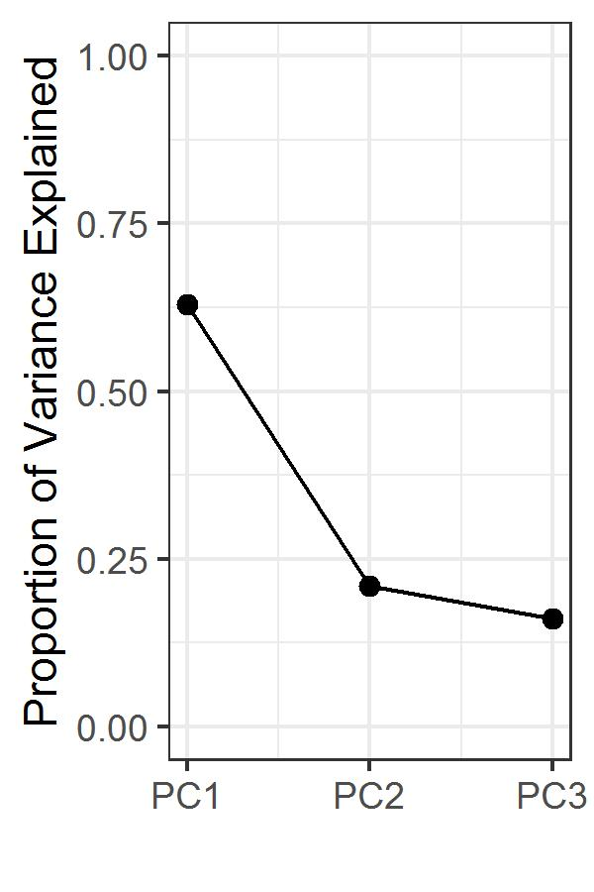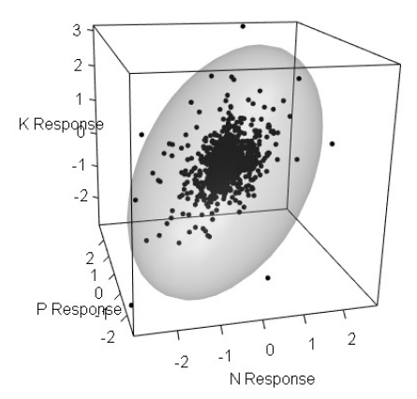

**Table 1**

Results of principal components analysis (PCA) of species responses to experimental fertilization treatments. Eigenvectors show positive variable loadings on the first principal component of all treatment responses, indicating that positively correlated responses to treatment form a dominant pattern in the data.

|  |  |  |  |  |
| --- | --- | --- | --- | --- |
| Principal Component Analysis | |  |  |  |
|  | PC1 | | PC2 | PC3 |
| Eigenvalue | 0.43 | | 0.25 | 0.22 |
| Proportion of Variance | 0.63 | | 0.21 | 0.16 |
| Cumulative Proportion | 0.63 | | 0.84 | 1.00 |
|  |  | |  |  |
| Eigenvectors |  | |  |  |
|  | PC1 | | PC2 | PC3 |
| N response | 0.64 | | -0.76 | 0.10 |
| K response | 0.53 | | 0.35 | -0.78 |
| P response | 0.55 | | 0.55 | 0.62 |

**Figure 3**

Major axis (MA) regression plots demonstrating pairwise correlations between estimated fertilization treatment responses. For each subplot, individual points represent estimated species responses to different limiting resources, colored by species functional group. Colored lines indicate best-fit lines produced by MA regression. Slope coefficients and contrasts between functional groups are presented in Table 2. Axes are displayed at log2 scale, such that a 1-unit increase corresponds to a doubling of species estimated cover.

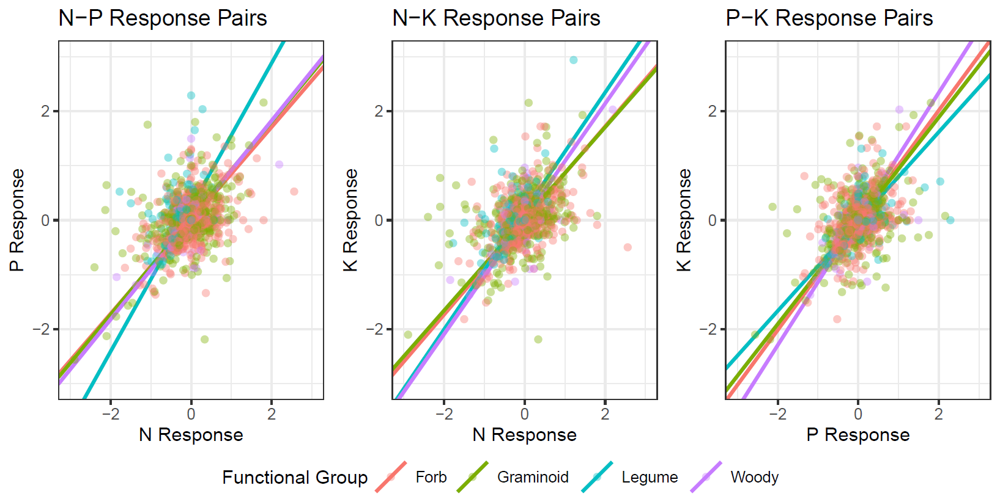

**Table 2**

Results of SMA model fitting to pairwise treatment responses. For each pairwise combination of treatment response coefficients, the within-group model R-squared, group slope, and post-hoc group labeling is presented. Groups where fitted slopes varied significantly (P < 0.05) were assigned different labels. P-values adjusted for multiple comparison using the Sidak correction. Generally, leguminous species often show distinct responses relative to other functional groups, particularly between estimated N and P response coefficients. Legumes appear to show greater specialization to P than other nutrients, exhibiting more extreme responses than would be expected given overall trends.

|  |  |  |  |  |  |  |  |  |  |  |
| --- | --- | --- | --- | --- | --- | --- | --- | --- | --- | --- |
|  |  | N - P | | | N - K | | | P - K | | |
| Functional Group | *n* | R-squared | Slope | Group | R-squared | Slope | Group | R-squared | Slope | Group |
| Forb | 1479 | 0.18 | 0.86 | 1 | 0.20 | 0.86 | 1 | 0.19 | 1.01 | 1 |
| Graminoid | 670 | 0.20 | 0.89 | 1 | 0.15 | 0.84 | 1 | 0.19 | 0.95 | 12 |
| Legume | 241 | 0.10 | 1.32 | 2 | 0.22 | 1.09 | 2 | 0.36 | 0.82 | 2 |
| Woody | 112 | 0.32 | 0.91 | 1 | 0.47 | 1.06 | 2 | 0.41 | 1.16 | 1 |

**Figure 4**

Histograms depicting the frequency of observed treatment response correlations across sites. For all three possible pairs of treatment responses, sites show positive average correlations between species responses to fertilization treatments. However, sites show significant variation in their observed treatment response correlations, ranging between moderately negatively correlated responses (-0.5) to very strongly positively correlated responses (>0.9).

